**Updating Firmware**

Download and unzip the file for 2.2 from the link

https://github.com/Altronic-LLC/Altronic-Public-Files/tree/main/AFR-500_Firmware_Releases

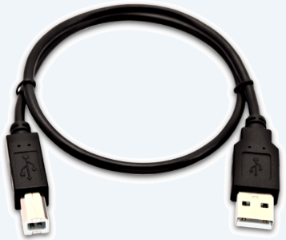The AFR-500 comes with a built in firmware downloader (commonly referred to a bootloader) that is used in conjunction with an Altronic made uploader file. Using an uploader file, it wraps the firmware in the file and communicates with the AFR-500 over a standard USB “A” to USB “B” cable.

The square USB “B” side of the cable plugs into the AFR-500 on the right side USB 0 port.

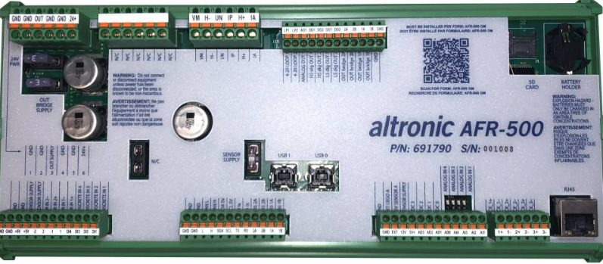

The USB “A” side of the cable plugs into your computer like any standard USB device.

Once you have the folder downloaded you will see the “AFR-500_Uploader x.x” where x.x is the version. 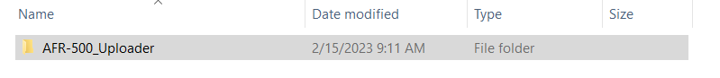

Contents inside the folder is the “AFR-500_upload” windows batch file. **NOTE: do not change this file name**

There is also a folder for helper files. These contain the actual firmware to be wrapped in the uploader file and you can verify it is correct by its version name, and two other files that help the uploader interact with the microcontroller specifically.

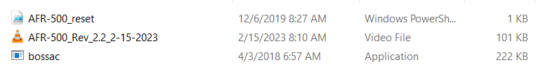

By double clicking the AFR-500_upload file you will be prompted with a window as shown below.

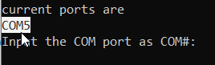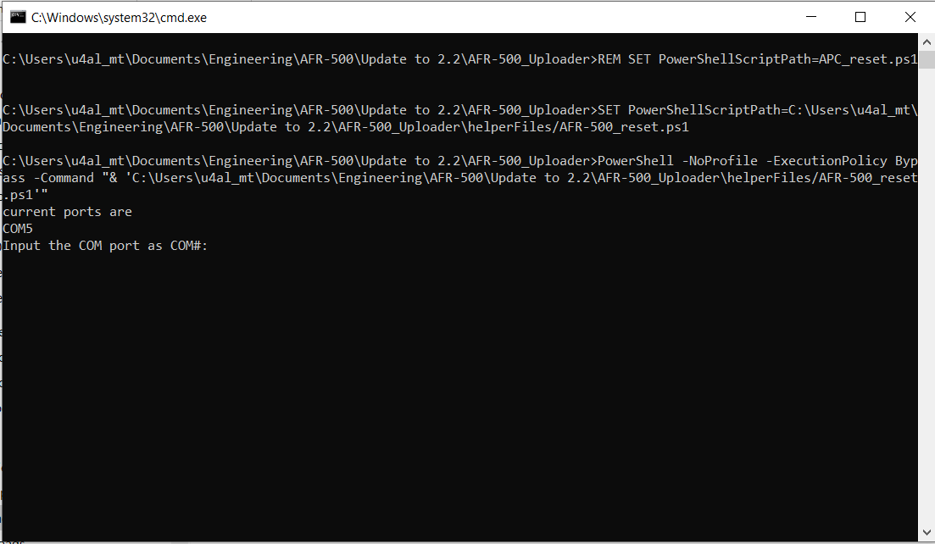

You will notice that it states what the current com ports available are. In this case it is COM5. You will need to enter “COMX” where the blinking cursor is.

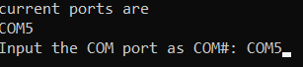

The device will go through a step to put the unit into a bootloader mode and will reset the board. Enter the COM port again in the blinking cursor. In most cases it will be a different COM port this time

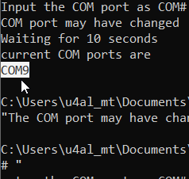

Enter the COM port as shown below and hit enter

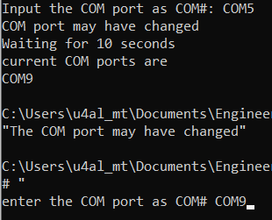

The device will go through the update process and will finish as shown below.

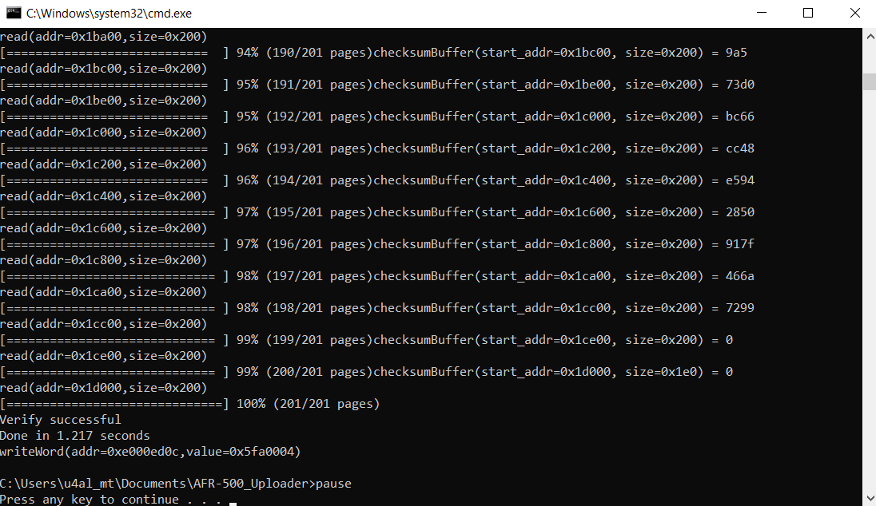

If you see something similar to the below screen, you have entered the wrong COMport, or something else is wrong. Contact the factory in this case.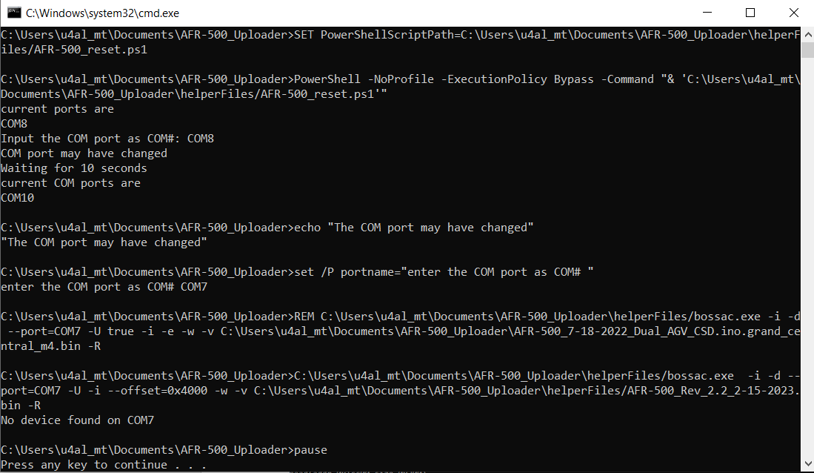

To verify that you have the correct firmware loaded, open a terminal tool like hyper term or putty and connect to the com port. You will see the below information.

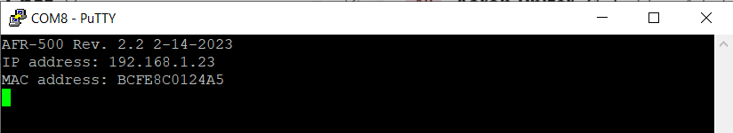

Updating PID registers

<https://www.altronic.a2hosted.com/doku.php?id=documents:afr-500:afr500operating>

<https://staging.altronic.a2hosted.com/doku.php?id=documents:awi:awi_connection/>

**Connect to the AFR-500 by using the available ethernet port on the ACM-4000**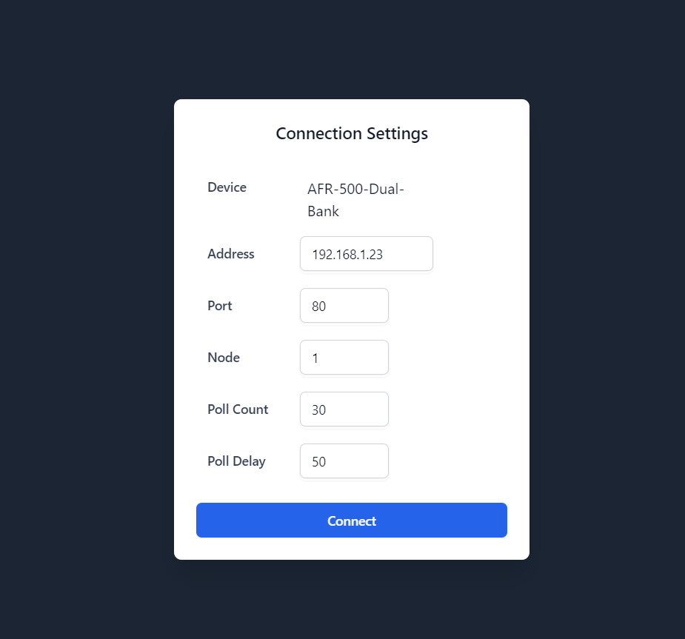

**Once connected, click the Debug tab on the left. (Be sure the device status says its connected and the BLUE LED is lit)**

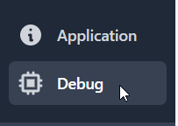

Once in the Debug tab, go to each of these registers, and enter the numbers as depicted below in the text input boxes. Double check you have the correct register number on the left. If you wanted to adjust PIDs or other factors, you can always come back here and use this page.









Input Box

Register number